MCPR/Michael Corrigan | michael@youneedmc.com | 720-470-2874

FOR IMMEDIATE RELEASE: Tuesday, April 9, 2024

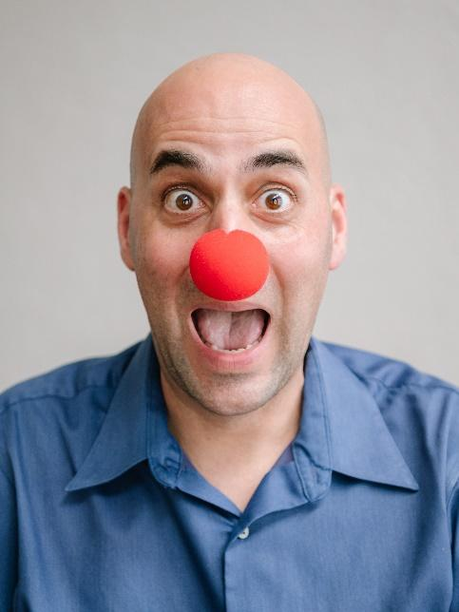
Scott Ehrenpreis stars in the solo show Clowns Like Me. Photo by Shyla Rose.

Scott Ehrenpreis Shares His Inspiring Mental Health Journey Juggling Autism Spectrum Disorder, OCD, Bipolar Disorder, Social Anxiety and Depression in the Comedic Solo Show

Clowns Like Me

New York City Off-Broadway Premiere at DR2

Limited Engagement runs June 21 - August 18

New York, NY -- Mental illness is no laughing matter, but in the new solo show Clowns Like Me, audience members are encouraged to laugh, cry and enjoy the ride into the unknown. Clowns Like Me will have its New York Off-Broadway Premiere at the DR2 Theatre this summer. The witty, timely, and inspiring story is based on Sarasota actor and storyteller Scott Ehrenpreis’ true life struggles with mental illness and its stigmas. The play was written by Jason Cannon, who also directs. Previews begin on June 21, for a limited engagement through August 18, 2024. Opening night is slated for Sunday, June 30 at 6:30pm.

Clowns Like Me was previously performed in Sarasota, Florida, to sold-out audiences and critical acclaim. Jay Handelman with The Sarasota Herald-Tribune described the show as “Brave, revelatory, joyous and cathartic,” as well as “entertaining and dramatic, personal and impactful.” Patrons likewise called the production “thought-provoking, compelling, and above all, extremely entertaining,” while another shared, “I found answers and closure to my son’s suicide that nothing in the past 10 years could give me.”

During its New York run, Clowns Like Me will be partnering with local community organizations that help give voice to mental illness issues. The show is thrilled to announce their first New York community partnership with the National Alliance on Mental Illness NAMI-NYC.

"We are proud to partner with Clowns Like Me, a production which breaks the stigma around living with mental illness for individuals and their families. We're excited to see NAMI-NYC featured in the show as a free mental health resource and community for New Yorkers and beyond," shared Matt Kudish, CEO of NAMI-NYC, helping individuals and families affected by mental illness with classes, support groups, family mentoring, a Helpline, and much more.

The main goals of the production are to inspire hope to anyone who is on a journey to achieve mental wellness and to provide a clearer understanding to those who have friends and family dealing with mental illness. Talkbacks with Scott and special guests will take place following each performance. Prior to opening Off-Broadway, Florida audiences will have the chance to see a fresh sneak preview of the New York show, May 23 – 26 at the Cook Theatre in Sarasota. For tickets and additional info, please visit: https://www.lifelineproductionsinc.org/clowns-like-me

About Clowns Like Me
In his deeply personal and universally resonant one-man show, seasoned actor and master storyteller Scott Ehrenpreis tells his humorous yet profound story of living with mental illness. Like, lots of mental illness.

Clowns Like Me fearlessly confronts the challenges of living with Autism Spectrum Disorder, OCD, bipolar disorder, social anxiety, and depression, weaving a tale that is as heartbreaking as it is inspiring. Through his journey, Scott uncovers a remarkable truth: the stage becomes his sanctuary, a place where, if only for a few hours, he can emerge from the shadows of his struggles into the spotlight of empowerment and self-expression.
Don't miss this unique and uplifting theatrical experience that promises not only to entertain but to illuminate the resilience of the human spirit. Clowns Like Me invites New York audiences to witness the transformative power of storytelling, where laughter and vulnerability collide to reveal the strength found in facing one's fears. Join Scott for an unforgettable evening complete with post-show talkbacks where the magic of theater becomes a beacon of hope and liberation for those impacted by mental illness.

Clowns Like Me is produced by Lifeline Productions with The Doll-Loesel Foundation, The Dena Wirt Trust, and by special arrangement with Daryl Roth Productions. The creative/production team includes lighting design by Xiangfu Xiao, production manager Tech Without Tears, general manager Mott/Fischer Productions, and executive producer Jonathan Demar.

Performances run Sundays at 5pm, Tuesdays – Fridays at 7:30pm, Saturdays at 3pm and 8pm, with a special holiday Wednesday matinee at 3pm on July 3rd. Opening night is scheduled for Sunday, June 30 at 6:30pm. Running time: 75 minutes. Tickets start at $49 and are currently on sale at www.clownslikeme.com, Telecharge, or by visiting the DR2 Theatre box office. DR2 is located at 103 E 15th Street in Union Square (between Park Ave, South and Irving Place). Recommended for ages 16 and up.

CLOWNS LIKE ME PRESS KIT

BIOGRAPHIES

Jason Cannon (playwright/director) is an award-winning actor, director, playwright, improviser, and teacher, as well as a best-selling author and publisher. He has an MFA in Directing, an MA in Drama, and over 25 years’ experience in professional theatre. Jason has 100+ credits as an actor, 120+ credits as a director, and Clowns Like Me is his ninth produced play as a playwright. Proud member AEA and SDC. www.jasoncannon.art

Scott Ehrenpreis (performer) earned a BFA in performance from Ohio University. Stage credits include Network, Smoke and Mirrors, and The Lehman Trilogy at Florida Studio Theatre, and Moon over Buffalo at The Player's Theatre. He played Ben Silverman in The Sunshine Boys (multiple productions), The Front Page at Asolo Repertory Theatre, and several shows and play festivals at Theatre Odyssey. Television credits include South Beach Tow (TruTV), as CIA officer in Burn Notice (USA Network), and as Isaac Andrews in Anastasia Avenue (web series). Film credits include I Am a White Blood Cell, The Actor, and Mr. Smiller.

Lifeline Productions (producer) is a 501 (c)(3) nonprofit that produces personal stories of those living with mental illness to create awareness, stimulate conversation, reduce stigmas, and foster hope and healing. For more information about “Clowns Like Me” and Lifeline Productions visit www.lifelineproductionsinc.org

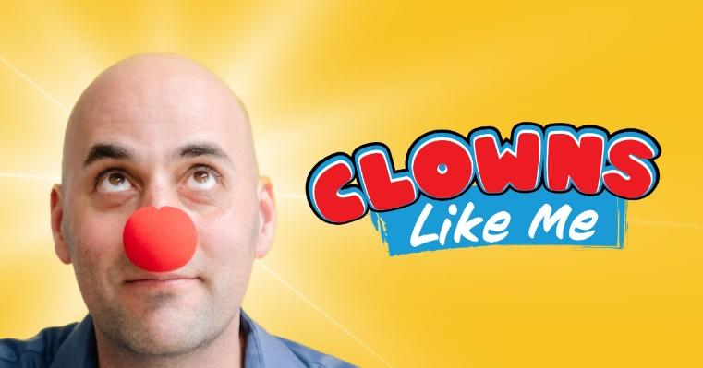

www.instagram.com/clownslikemeshow
https://www.facebook.com/ClownsLikeMe

# # #

